Data Flow Diagram
Date | 30 September 2026
Team ID | SWTID-2026-3379
Project Name | AI Weather Wise
Team Size | 4
Team Leader | PREETHI L
Team Members | DEVI PRIYA S, SUMITHRA G, SIPORAL U
Maximum Marks | 2 Marks

Data Flow Diagram
The Data Flow Diagram (DFD) shows how data moves through AI Weather Wise between external entities, processes and data stores. It follows the symbol legend of the official template.

DFD Symbol Legend
Symbol | Name | Used in AI Weather Wise
Oval / rounded shape | External Entity | USER; WEATHER API
Rectangle with numbered header | Process | 1.0 Enter Location / Request Weather; 2.0 Fetch Weather Data; 3.0 Analyze Weather / Generate Guidance; 4.0 Display Forecast & Guidance
Rectangle (solid fill, no number) | Data Store | D1 - Weather Data; D2 - User Preferences
Labeled arrow | Data Flow | Location, weather request, API request, JSON response / error, processed data, guidance

Level 0 - Context Diagram
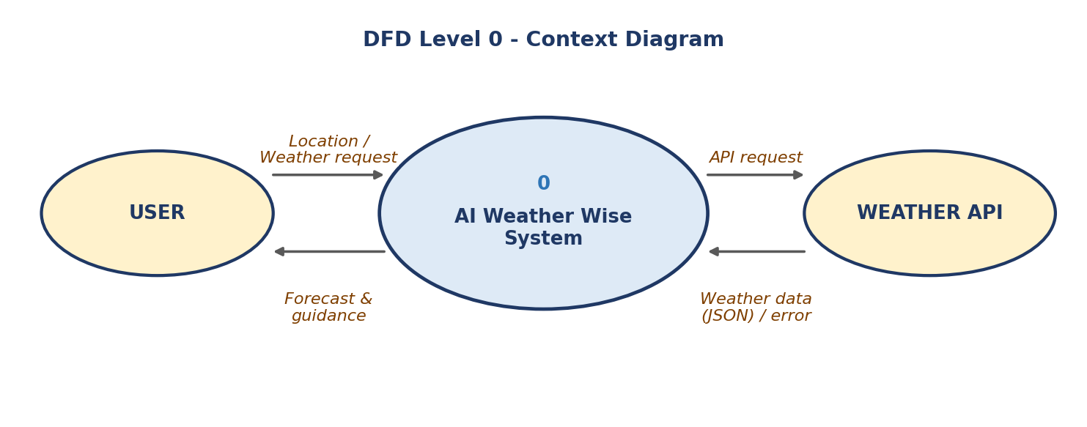
Figure 1: DFD Level 0 for AI Weather Wise

Level 1 - Main Processes
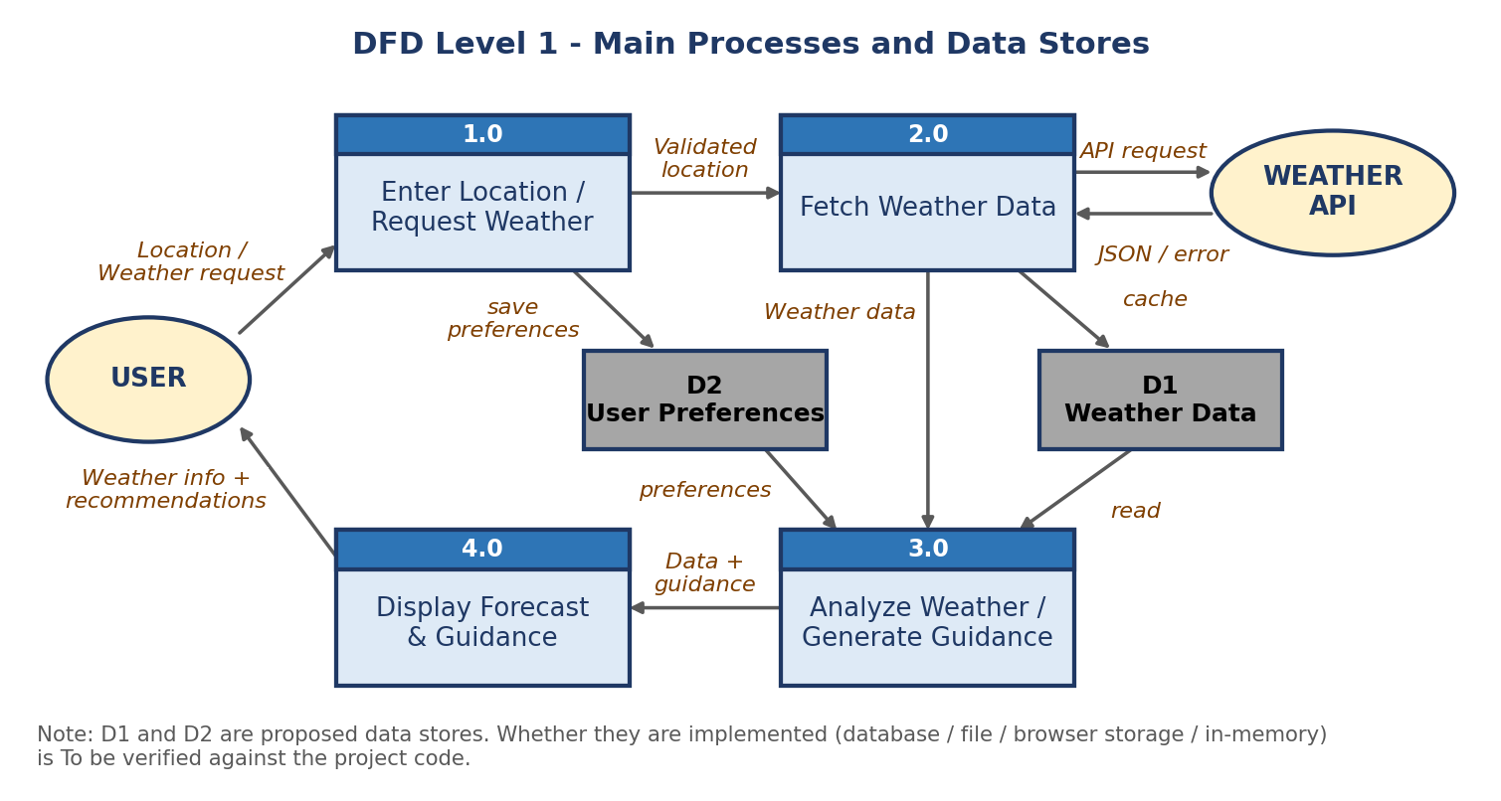
Figure 2: DFD Level 1 for AI Weather Wise

Textual Flow
USER → Location / Weather Request → 1.0 Enter Location / Request Weather → 2.0 Fetch Weather Data ↔ Weather API → 3.0 Analyze Weather / Generate Guidance → 4.0 Display Forecast & Guidance → USER

Process Descriptions
Process | Description | Input | Output
1.0 Enter Location / Request Weather | Accepts the location typed by the user, validates that it is not empty and passes a clean request onward. | Location / weather request | Validated location
2.0 Fetch Weather Data | Sends a request to the Weather API with the location and API key and receives the response; handles invalid location and API errors. | Validated location; API response | Weather data (JSON) or error message
3.0 Analyze Weather / Generate Guidance | Extracts required fields (temperature, condition, humidity, wind, rain, forecast) and applies rule-based / AI logic to create recommendations. | Weather data; user preferences (optional) | Processed weather data and guidance
4.0 Display Forecast & Guidance | Shows current weather, forecast, recommendations or a friendly error message on the interface. | Processed data and guidance | Weather information and recommendations shown to USER

Data Stores
Data Store | Contents | Written By | Read By | Implementation Status
D1 - Weather Data | Most recent weather response for a location (temporary / cache) | 2.0 Fetch Weather Data | 3.0 Analyze Weather / Generate Guidance | To be verified
D2 - User Preferences | Optional settings such as temperature unit or last searched location | 1.0 Enter Location / Request Weather | 3.0 and 4.0 | To be verified

Note: D1 and D2 are the possible data stores given in the project brief. It is To be verified whether they exist in the final code (for example as a database, file, browser storage or in-memory variable). If the application does not store data, the diagram should be read as showing temporary in-memory data only.

